Tool Manual

This document gives detailed overview of the tools, which shall be used while preparing the best Hamburger.

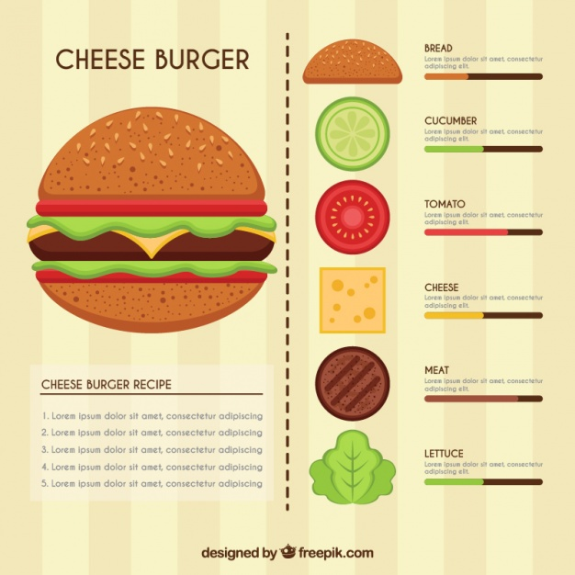

**TABLE OF CONTENTS**

|  |  |  |
| --- | --- | --- |
| Serial Number | Content | Page Number |
| 01 | Mixer/Grinder | 02 |
| 02 | Mixing Bowl | 02 |
| 03 | Knife | 03 |
| 04 | Chopping Board | 03 |
| 05 | Fry Pan | 03 |
| 06 | Spatula | 04 |
| 07 | Spoons | 04 |

1. **Mixer/Grinder:** Mixer Grinder –are known for handling multiple chores. Such as grinding food ingredients, grating Coconut, making puree, mincing, powdering spices and chopping of fruits and vegetables.

You will use the grinder to ground the chicken into a fine paste for preparing the patties for the hamburger. For your ingredient, you will need to use the grinder which has a wet grinding base.

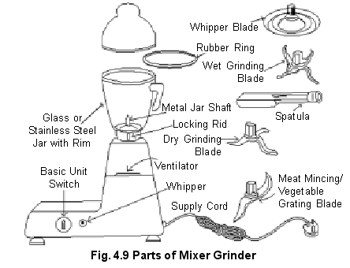

Since an average grinder is of 1-liter capacity, we will have to ground 500 grams of meat at each go.

1. **Mixing Bowl**: A plain steel/glass bowl of 2 liters will suffice for mixing all the spices and wet ingredients with the ground meat. The bowl having a larger circumference than depth is best suitable for easy mixing of the meat.

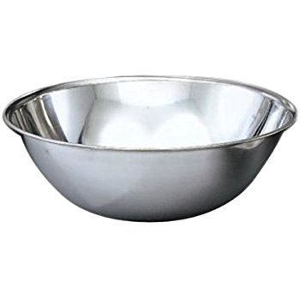

1. **Knife**: A sleek and sharp kitchen knife will be used for slicing the meat for easy grinding and for chopping the fresh vegetables for layering on the patty.

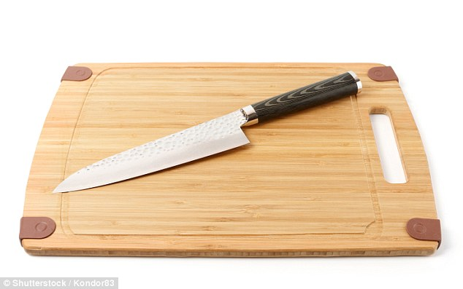

1. **Chopping Board:** For clean chopping of the vegetables.
2. **Fry Pan:** A Frying Pan-typically a shallow pan with a long handle. It will be used for toasting the hamburger buns and the patties in piping hot oil.

A non-stick frying pan with a diameter of 26-28 centimeters across would be the best suited for quick frying of the patties.

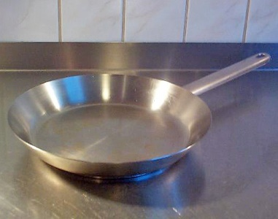

1. **Spatula**: Spatula-is an implement with a broad, flat, blunt blade, used for mixing and spreading things in cooking.

You will need a fish spatula for they are angled for easy flipping of the sticky patties in the pan. Fish spatulas will also aid you to drain excess oil from the fried patties.

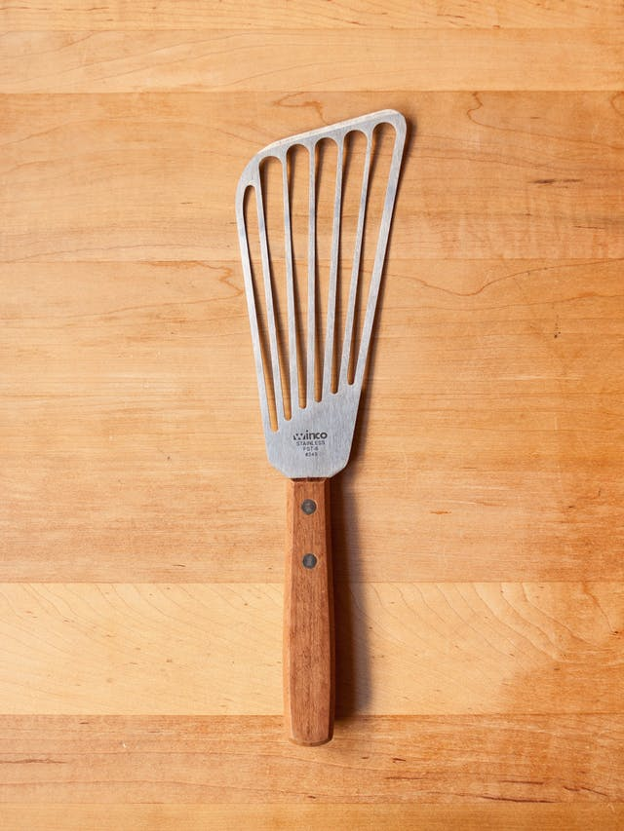

1. **Spoons**: Spoons will be required in for everything starting from mixing the meat with other ingredients, measuring oil, spreading condiments on the burger buns.

You would only require regular teaspoons during this preparation.